Designing the login page

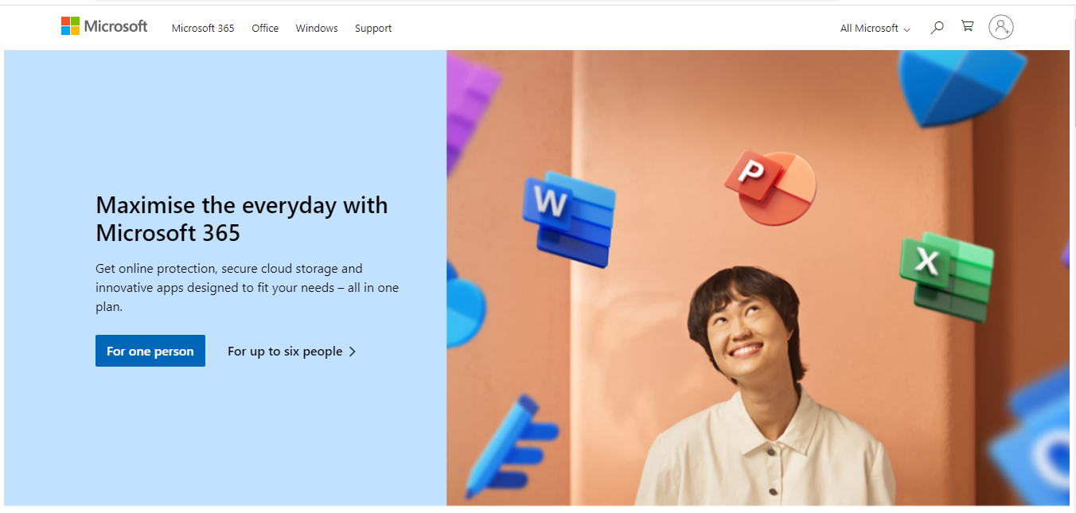

Step 1 :Create the NAVBAR

<div class=”navbar flex justify-between items-center” > navbar not class

Small bar lines on top left corner

Create another and three div for creating lines of multiline bar

        <div class="line h-0.5 w-6 my-1 bg-black"></div>

Step 2

Create the Microsoft log. The second item of navbar and adjacent to above div

Create Cart Account and search in navbar

Group bar lines and search using div

Make Bars and Search responsive by hidden bar at md level e.g. md:hidden and change order of search by md:order-2

We want to hide the bars and give change the search order when screen size increase to md: order-2

Output before md point



Output after md point



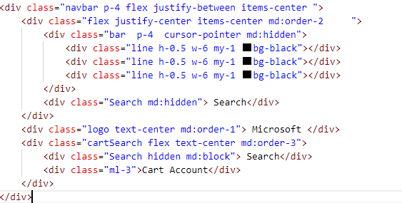

Step 3

Add other menu bar items and make it responsive.

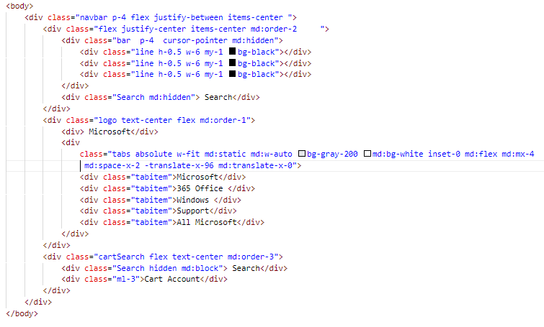

Step 4

Left and Right Side

Hint:

Span and div are both generic HTML elements that group together related parts of a web page. However, they serve different functions. A div element is used for block-level organization and styling of page elements, whereas a span element is used for inline organization and styling

Inline-block: **display: inline-block** will wrap the element to prevent the text inside from extending beyond its parent.

Copy menu items from

Microsoft website: and place in separate editor

Multicursor alt shift

Space-x-1 for space in div item horizontly

absolute: Use. absolute to position an element outside of the normal flow of the document, causing neighbouring elements to act as if the element doesn't exist.